**LISTENING SOLUTION 05**

**TASK 01**

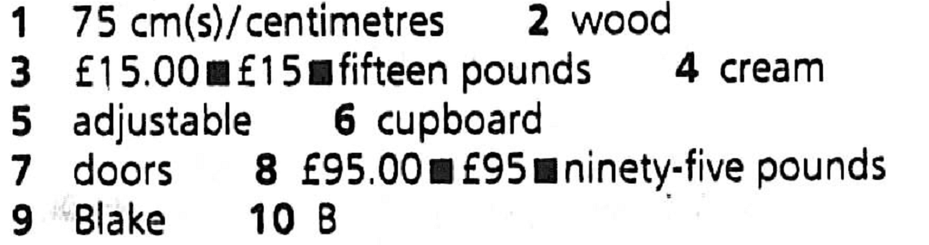

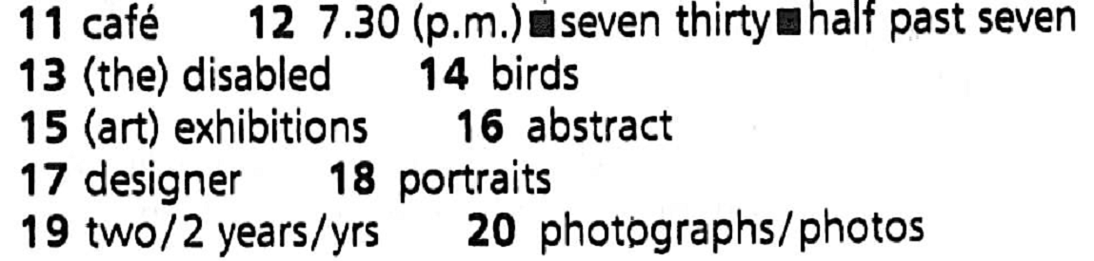

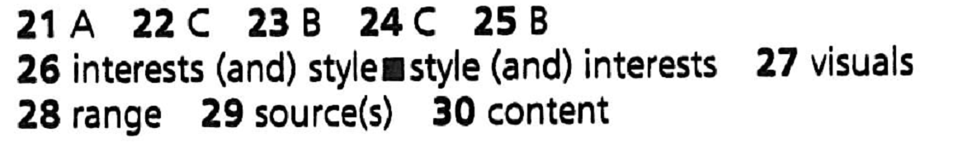

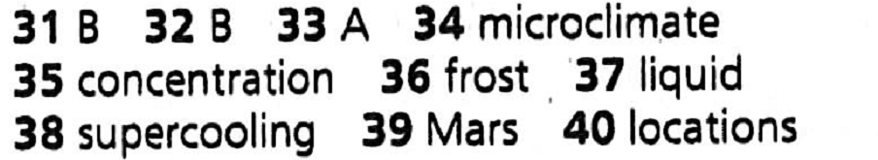

**02. Task 02 :**

**SECTION 01**

Mrs Blake: Hello?

Conor: Oh, hello. I'm ringing about the advertisement in yesterday's newspaper... the one for the bookcases.., can you tell me if they're still available?

Mrs Blake: We've sold one, but we still have two available.

Conor: Right. Er... can you tell me a bit about them?

Mrs Blake: Sure, er... what do you want to know?

Conor: Well, t'm looking for something to **fit** in my study, so, well, I'm not too **worried** about the **height**, but the **width's** quite important. Can you tell me how wide each of them is?

Mrs Blake: They're both exactly the same size ... let me see, I've got the **details** **written** down somewhere, Yes, so they're both 75 cm wide and 180 cm high.

Conor: OK, fine, that should fit in OK. And don't want anything that looks too **severe** ... not made of **metal**, for example. I was really looking for something made of **wood**?

Mrs Blake: That's all right, they are, both of them.

Conor: So, are they both the same price as well?

Mrs Blake: No, the first **bookcase** is quite a bit cheaper. It's just £15.00. We paid £60.00 for it just five years ago, so it's very good value. It's in perfectly good condition, they're both in very good condition in fact, but the first one isn't the same quality as the other one. It's a good **sturdy** bookcase, it used to be in my son's room, but it could do with a fresh **coat** of paint,.,

Conor: Oh, it's painted?

Mrs Blake: Yes, it's **cream** at present, but as I say you could easily change that if you wanted ... to fit in with your colour **scheme**.

Conor: Yes, I'd probably paint it white if I got it. Let's see, what else... how many shelves has it got?

Mrs Blake: Six-two of them are fixed, and the other four are **adjustable** so you can shift them up and down according to the sizes of your books.

Conor: Right, fine. Well that certainly sounds like a possibility.

Mrs Blake: But the second one's a lovely bookcase too. That's not painted, it's just the **natural** wood colour, a **dark** **brown**. It was my grandmother's, and I think she bought it sometime in the 1930s so I'd say it must be getting on for eighty years old, it's very good quality, they don't make them like that nowadays.

Conor : And you said it's the same **dimensions** as the first one?

Mrs Blake: Yes, and it's got the six shelves, but it also has a **cupboard** at the bottom that's really useful for keeping **odds** and **ends** in.

Conor: Right.

Mrs Blake: Oh, and I nearly forgot to say, the other thing about it is it's got glass doors, so the books are all kept out of the **dust**. So it's really good value for the money. I'm

really sorry to be selling it but we just don't have the room for it.

Conor: Mmm. So what are you asking for that one?

Mrs Blake: £95.00. It's quite a bit more, but it's a lovely piece of furniture - a real **heirloom**.

Conor: Yes... all the same, it's a lot more than I wanted to pay ... I didn't really want to go above thirty or forty. Anyway, the first one sounds fine for what I need.

Mrs Blake: Just as you like.

Conor: So is it all right if I come round and have a look this evening, then if it's OK I can take it away with me?

Mrs Blake: Of course. So you'll be coming by car, will you?

Conor: I've got a friend with a van, so I'll get him to bring me round, if you can just give me the details of where you live.

Mrs Blake: Sure. I'm Mrs Blake, ...

Conor: B-L-A-K-E?

Mrs Blake: That's right, and the address is 41 Oak Rise, that's in Stanton.

Conor: OK ... so I'll be coming from the town centre, can you give me an idea of where you are?

Mrs Blake: Yes, you know the road that goes out towards the university?

Conor: Yes.

Mrs Blake: Well you take that road, and you go on till vou get to a **roundabout**, go straight on, then Oak Rise is the first road to the right.

Conor: Out towards the university, past the roundabout, first left?

Mrs Blake: First right. And we're at the end of the road.

Conor: Got it. So I'll be round at about 7.00, if that's all right. Oh, and my name's Conor... Conor Field.

Mrs Blake: Fine. I'll see you then, Conor. Goodbye.

Conor: Goodbye.

SECTION 02

**Announcer:** One of the most anticipated art events in Christchurch is the Charity Art Sale, organised this year by Neil Curtis. Neil, tell us all about it.

**Neil:** Well, Diane, this looks like being the biggest art sale yet, and the best thing about it is that the money raised will all go to charity. So what you probably want to know first is where it is. Well, the pictures will be on view all this week, most of them at the Star Gallery in the shopping **mall**, but we have so many pictures this year that we're also showing some in the safe next door, so do drop in and see them any day between 9.00 and 5.00. Now if you're interested in buying rather than just looking - and we hope a lot of you will be - the actual sale will take place on Thursday evening, with sales starting at 7.30 - **refreshments** will be available before the sale, starting at 6.30. We've got about 50 works by local artists showing a huge range of **styles** and media, and in a minute I'll tell you about some of them. You're probably also interested in what's going to happen to your money once you've handed it over - well, all **proceeds** will go to support children who are **disabled**, both here in New Zealand and also in other countries, so you can find an original painting, support local **talent**, and help these children all at the same time.

Now let me tell you a bit about some of the artists who have kindly agreed to **donate** their pictures to the Charity Art Sale.

One of them is Don Studley, who has a special interest in the art sale because his five-year-old daughter was born with a serious back problem. After an **operation** earlier this year, she's now doing fine, but Don says he wants to offer something to help other less **fortunate** children. Don is totally self taught, and says he's **passionate** about painting ’ His paintings **depict** some of our New Zealand bird in their natural habitats.

One relative newcomer to New Zealand is James Chang, who came here from Taiwan nine years ago, at the age of 56. Mr Chang had 13 exhibitions in Taiwan before he came to live here in Christchurch so he's a well-established artist and art has been a **lifelong** **passion** for him. His paintings are certainly worth looking at - if you like **abstract** pictures with strong colour schemes, you'll love them.

Natalie Stevens was born in New Zealand, but has exhibited in China, Australia and Spain. As well as being an artist, she's a website designer. She believes art should be **universal**, and her paintings use soft colours and a mixture of media. Most of her pictures are **portraits** so watch out - some of them may even be friends of yours.

And then we have Christine Shin, from Korea. Christine only started to learn English two years ago, when she arrived in New Zealand, but she's been painting **professionally** for over ten years and she sure knows how to communicate strong messages through the universal language of art. She usually works from photographs, and paints **delicate** watercolours, which combine traditional Asian **influences** with New Zealand **landscapes**, giving a very special view of our local **scenery**.

Well, that's all I have time to tell you now, but as well as these four, there are many other artists whose work will be on sale so do come along on Thursday. We accept cheques, credit cards or cash and remember, even if you don't buy a picture you can always make a **donation**!

SECTION 03

Olivia: Hi, Joey. How are you doing? I heard you were sick.

Joey: Oh, hi, Olivia. Yeah, I had a virus last week, and I missed a whole pile of lectures, like the first one on the Great Books in Literature ... where Dr Castle gave us all the information about the semester project.

Olivia: I can give you copies of the handouts, I've got them right here.

Joey: That's OK. I already collected the handouts but I'm not very clear about all the details... I know we each have to choose an individual author... I think I'm going to do Carlos Castenada ... I'm really interested in South American literature.

Olivia: Have you checked he's on the list that Dr Castle gave us? We can't just choose anyone.

Joey: Yeah, I checked, it's OK. Who did you choose?

Olivia: Well, I was thinking of choosing Ernest Hemingway, but then I thought no, I'll do a British author not an American one, so I chose Emily Bronte.

Joey: OK ... and first of all it says we have to read a biography of our author - I guess it's OK if we iust lookup.. information about him on the Internet?

Olivia: No. it's got to be a full-length book. I think the minimum length's 250 pages... there's a list of biographies, didn't you get that?

Joey: Oh right. I didn't realise we had to stick with that. So what do we have to do when we've read the biography?

Olivia: Well, then we have to choose one work by the writer... again it's got to be something quite long, we can't just read a short story.

Joey: But I guess a collection of short stories would be OK?

Olivia: Yes, or even a collection of poems, they said, but I think most people are doing novels. I'm going to do Wuthering Heights, I've read it before but I really want to read it again now I've found out more about the writer.

Joey: And then the video ... we have to make a short video about our author and about the book. How long has it got to be?.

Olivia: A minute.

Joey: What? Like, sixty seconds? And we gotta give all the important information about their life and the book we choose ...

Olivia: Well you can't do everything ... I wrote it down somewhere ... yes, Dr Castle said we had to find or write a short passage that helps to explain the author's passion for writing, why they're a writer'. So. we can back this up. with reference to important events in the writer's life if they're relevant, but it's UP to us really. The video's meant to portray the essence of the writer's life and the piece of writing we choose.

Joey: So when we read the biography, we have to think about what kind of person our writer is...

Olivia: Yes... and the historical context and so on. So for my writer, Emily Bronte, the biography gave a really strong impression of the place where she lived and the countryside around.

Joey: Right, I'm beginning to get the idea.

Joey: Er... can I check the other requirements with you?

Olivia: Sure.

Joey: The handout said after we'd read the biography, we had to read the work we'd chosen by our author and choose a passage that's typical in Some way ... that typifies the author's interests and style.

Olivia: Yes, but at the same time it has to relate to the biographical extract you choose ,., there's got to be some sort of theme linking them.

Joey: OK, I'm with you.

Olivia: And then you have to think about the video.

Joey: So are we meant to dramatise the scene we choose?

Olivia: I guess we could, but there's not a lot of time for that... I think it's more how we can use things like sound effects to create the atmosphere ... the feeling we want.

Joey: And presumably visuals as well?

Olivia: Yeah, of course - I mean, I suppose that's the whole point of making a video - but whatever we use has to be historically in keeping with the author. We can use things like digital image processing to do it all.

Joey: So we can use any computer software we want?

Olivia: Sure. And it's important that we use a range - not just one software program. That's actually one of the things we're assessed on.

Joey: OK.

Olivia: Oh, and something else that's apparently really important is to keep track of the materials we use and to acknowledge them.

Joey: Including stuff we download off the Internet presumably?

Olivia: Yeah, so our video has to list all the material used with details of the source in a bibliography at the end.

Joey: OK. And you were talking about assessment of the project - did they give us the criteria? I couldn't find anything on the handout.

Olivia: Sure. He gave us them in the lecture. Let's see, you get 25 percent just for getting all the components done - that's both sets of reading, and the video. Then the second part is actually how successful we are at getting the essence of the work, they call that 'content' and that counts for 50 percent. Then the last 25 percent is on the video itself, the artistic and technical side.

Joey: Great. Well, that sounds a lot of work, but a whole lot better than just handing in a paper. Thanks a lot, Olivia

Olivia: You're welcome.

**SECTION 04**

Hello, everybody, and welcome to the **sixth** of our **Ecology** evening classes. Nice to see you all again. As you know from the programme, today I want to talk to you about some research that is pushing back the **frontiers** of the whole **field** of ecology. And this research is being carried out in the **remoter** regions of our planet... places where the environment is **harsh** and - until recently - it was thought that the conditions couldn't **sustain** life of any kind. But, life forms are being found - and these have been **grouped** into what is now known as **extremophiles** - that is, **organisms** that can survive in the most extreme environments. And these discoveries may be setting a huge challenge for the scientists of the future, as you'll see in a minute.

Now, the particular research I want to tell you about was carried out in **Antarctica** - one of the coldest and **driest** places on Earth. But a **multinational** team of researchers

- from the US, Canada and New Zealand - recently discovered **colonies** of **microbes** in the soil there, where no one thought it was possible. Interestingly enough, some of the colonies were identified as a type of **fungus** called Beauveria Bassiana - a fungus that lives on **insects**. But where are the insects in these **utterly** empty **regions** of Antarctica? The researchers concluded that this was clear evidence that these colonies were certainly not new **arrivals** ... they might've been there for centuries, or even **millennia** - possibly even since the last Ice Age! Can you imagine their excitement? .

Now, some types of microbes had previously been found living just a few millimetres under the surface of rocks - **porous**, Antarctic rocks... but this was the first time that living colonies had been found surviving - erm - relatively deeply in the soil itself, several centimetres down in fact.

So, the big question is: how can these **colonies** survive there? Well, we know that the organisms living very near the rock surface can still be warmed by the sun, so they can survive in their own **microclimate** ... and this keeps them from freezing during the day. But this isn't the case for the colonies that are **hidden** under the soil.

In their research paper, this team suggested that the very high amounts of salt in the soil might be the **clue** - because this is what is preventing **essential** water from freezing.

The team found that the salt concentration increased the deeper down they went in the soil. But while they had expected the number of organisms to be fewer down there, they actually found the **opposite**. In soil that had as much as 3000 parts of salt per million, relatively high numbers of microbes were present - which seems incredible. But the point is that at those levels of salt, the temperature could drop to minus 56 degrees before **frost** would cause any damage to the organisms.

This relationship between microbes and salt - at temperatures way below the normal freezing point of water - is a really significant **breakthrough.** As you all know, life is dependent on the availability of water in liquid form, and the role of salt at very low temperatures could be the key to survival in these kinds of conditions. Now the process at work here is called **supercooling** - and that's usually written as one word - but it isn't really understood as yet, so, there's a lot more for researchers to work on. However, the fact that this process occurs naturally in Antarctica, may suggest that it might occur in other places with similar conditions, including on our **neighbouring** planet, Mars. So, you can start to see the wider **implications** of this kind of research.

In short, it appears to support the growing belief that **extraterrestrial** life might be able to survive the dry, cold conditions on other planets after all. Not only does this research produce evidence that life is possible there, it's also informing scientists of the locations where it might be found. So all of this might have great **significance** for future **unmanned** space missions.

One **specialist** on Mars confirms the importance ...